

Coursework 2: Practical Data Analytics Report

A Data-Driven Analysis and Predictive Modelling of Urban Air Pollution and Asthma-Related Health Outcomes in London Using Integrated Machine Learning Approaches.

Student Id: A00097534
Student Name: Tanusree Nagesh

CODE FILE
https://github.com/tanunageshh-rgb/Data-Analytics-coursework-2

TABLE OF CONTENTS

ABSTRACT………………………………………………………………………………………..4
- INTRODUCTION……………………………………………………………………............5
- MOTIVATION……………………………………………………………………………….5
- RESEARCH PROBLEM AND OBJECTIVES………………………………………….....6
3.1 OBJECTIVES OF THE STUDY…………………………………………………………..6
- LITERATURE REVIEW…………………………………………………………………….6
4.1 AIR POLLUTION AND PUBLIC HEALTH………………………………………………6
4.2 URBAN AIR POLLUTION IN LONDON…………………………………………………7
4.3 AIR POLLUTION AND RESPIRATORY HEALTH OUTCOMES………………............7
4.4 JUSTIFICATION OF HEALTH OUTCOME SELECTION………………………............8
4.5 DATA AND METHODOLOGICAL APPROACHES…………………………………….8
4.6 DATA ANALYTICS METHODS IN ENVIRONMENTAL HEALTH RESEARCH……..9
4.7 MACHINE LEARNING APPLICATIONS IN AIR QUALITY STUDIES……………….9
4.8 ROLE OF METEOROLOGICAL FACTORS…………………………………………….10
4.9 COMPARISON OF EXISTING STUDIES…...…………………………………………..10
4.10 RESEARCH GAP AND CONTRIBUTION……………………………………………..12
4.11 JUSTIFICATION OF SELECTED MODELS…………………………………………...12
4.12 TEMPORAL AND SEASONAL PATTERNS…………………….…………………......13
5. DATA………...………………………………………………………………………………....13
6. EXPLORATORY DATA ANALYSIS (EDA)…………………………………………..….....14
6.1 TEMPORAL TRENDS ANALYSIS………….…………………….………………….....14
6.2 DISTRIBUTION ANALYSIS………………...…………………….………………….....15
6.3 CORRELATION ANALYSIS……………….. …………………….………………….....15
6.4 ADVANCED EXPLORATORY DATA ANALYSIS …………………….……………....16
6.5 SUMMARY STATISTICS……………………………………………….…………….....17

7. DATA PREPROCESSING……………………………………………………………….......18
8. FEATURE SELECTION AND ENGINEERING……………………………………..…....19
9. METHODOLOGY....……………………...……………………………………………..…...20
10. DATA ANALYSIS………………………...………………………………………………....21
10.1 CROSS-VALIDATION…………..………….…………………….…………………....23
11. RESULTS AND DISCUSSION………………………………………………………..…....24
11.1 INTERPRETATION AND POLICY IMPLICATIONS………….…………………......25
11.2 LIMITATIONS OF THE MODEL……………………………….…………………......26
12. FEATURE IMPORTANCE ANALYSIS……………...………………………………...…27
12.1 COMPARISON WITH PREVIOUS………………… ………….…………………......29
12.2 FUTURE WORK……………………………………..………….…………………......29
13. CONCLUSION………………………..……………...………………………………..…....30
14. REFERENCES………………………. ……………...………………………………..…....31

Abstract:
Air pollution is a major environmental and public health concern in urban areas such as London, where emissions from transport and industrial activities contribute to elevated pollutant levels. Exposure to pollutants such as particulate matter (PM2.5 and PM10), nitrogen dioxide (NO₂), and ozone (O₃) has been strongly associated with respiratory diseases (World Health Organization, 2021). This study focuses on asthma-related hospital admissions as a measurable health outcome.
The research integrates air quality, meteorological, and health datasets to analyse the combined effects of environmental factors on respiratory health. Data preprocessing techniques, including missing value handling, temporal alignment, and dataset merging, were applied to ensure consistency. Exploratory Data Analysis (EDA) was conducted to identify trends, seasonal patterns, and correlations between variables.
Two analytical models were implemented: Linear Regression and Random Forest Regression. Model performance was evaluated using Mean Squared Error (MSE) and R-squared (R²), along with 5-fold cross-validation to ensure robustness. The results indicate that PM2.5 and NO₂ are the most significant predictors of asthma-related hospital admissions. Random Forest outperformed Linear Regression, demonstrating superior predictive capability.
This study contributes to existing research by integrating multiple datasets and applying machine learning techniques to provide insights for public health policy and environmental management.

1. Introduction:
Air pollution is a critical environmental challenge, particularly in densely populated urban areas such as London. Pollutants including particulate matter (PM2.5 and PM10), nitrogen dioxide (NO₂), and ozone (O₃) have been strongly associated with respiratory and cardiovascular diseases (World Health Organization, 2021; Schraufnagel et al., 2019). Among these, PM2.5 poses significant health risks due to its ability to penetrate deep into the lungs and bloodstream (Pope and Dockery, 2006).
Urban environments are especially vulnerable due to high traffic density and industrial emissions. Nitrogen dioxide, primarily produced by road transport, is strongly linked to asthma exacerbation and reduced lung function (Khreis et al., 2017). Despite regulatory interventions by organisations such as DEFRA (2022), pollution levels in London continue to exceed recommended thresholds.
2. Motivation:
Air pollution is widely recognised as a leading environmental risk factor with significant impacts on human health. Globally, millions of premature deaths each year are attributed to exposure to polluted air (World Health Organization, 2021). In densely populated urban environments such as London, the effects of air pollution are particularly severe.
There has been a noticeable increase in respiratory illnesses, especially asthma, among urban populations in recent years. Vulnerable groups, including children, elderly individuals, and those with pre-existing health conditions, are disproportionately affected. During periods of elevated pollution, hospitals often report a rise in respiratory-related admissions (NHS, 2022).
For instance, during heatwaves or periods of heavy traffic congestion, pollutant concentrations such as ozone and nitrogen dioxide can increase significantly, leading to worsening respiratory symptoms. These real-world scenarios highlight the direct impact of environmental conditions on public health.
The motivation for this study is to understand how air pollution and meteorological factors influence respiratory health outcomes. By applying data analytics to real-world datasets, this research demonstrates how data-driven insights can support effective environmental management and public health decision-making.

3. Research Problem and Objectives:
Urban air pollution remains a persistent public health challenge in major cities, including London. Despite regulatory efforts, many urban residents continue to be exposed to harmful levels of air pollutants. Understanding how air quality affects respiratory health outcomes is essential for developing effective interventions.
A key challenge in this area is the integration of diverse datasets, including air quality measurements, healthcare data, and meteorological information. These datasets often differ in structure, format, and temporal resolution, making analysis complex.
This study addresses this challenge by combining multiple datasets to explore the relationship between environmental conditions and respiratory health outcomes in London, with a focus on asthma-related hospital admissions.

3.1 Objectives of the Study:
- To analyse temporal and seasonal trends in air pollution
- To examine the relationship between pollutant levels and asthma-related hospital admissions
- To integrate environmental, meteorological, and health datasets
- To apply statistical and machine learning models
- To compare model performance
- To provide insights for policy recommendations

4. Literature Review:

4.1 Air Pollution and Public Health
Air pollution is widely recognised as a major environmental determinant of health, particularly in densely populated urban environments where emissions from transport and industrial activities are high. Numerous studies have established strong links between pollutant exposure and adverse respiratory outcomes (Schraufnagel et al., 2019). Early research by Pope and Dockery (2006) demonstrated a significant association between long-term exposure to fine particulate matter (PM2.5) and increased mortality risk. While these findings provide robust epidemiological evidence, they primarily focus on long-term exposure and do not capture short-term fluctuations in pollution levels.
In contrast, Brunekreef and Holgate (2002) incorporated time-series analysis to examine short-term exposure effects, showing that daily variations in pollution can significantly influence respiratory health outcomes. This highlights an important distinction between long-term and short-term analytical approaches. However, both approaches face limitations in integrating high-resolution environmental and health datasets.

4.2 Urban Air Pollution in London
London has been extensively studied due to its persistent air quality challenges. Despite regulatory measures implemented by organisations such as DEFRA (2022), pollution levels in certain areas continue to exceed recommended thresholds. Modern pollution sources are primarily linked to road transport, with nitrogen dioxide (NO₂) being a major pollutant in high-traffic areas.
Studies using data from the London Air Quality Network (LAQN) have enabled detailed spatial and temporal analysis of pollutant concentrations. These studies indicate that pollution exposure is unevenly distributed across the city, with higher concentrations observed in urban hotspots. Furthermore, meteorological conditions such as temperature, wind speed, and rainfall significantly influence pollutant dispersion and concentration levels.

4.3 Air Pollution and Respiratory Health Outcomes
The relationship between air pollution and respiratory diseases has been widely documented, with asthma identified as one of the most sensitive health outcomes. Studies such as Khreis et al. (2017) demonstrate a strong association between traffic-related pollution and increased asthma incidence.
Short-term exposure to pollutants such as PM2.5, NO₂, and ozone has been linked to increased hospital admissions and emergency visits. Time-series studies show a clear temporal relationship between pollution spikes and asthma-related health outcomes. However, many of these studies rely on aggregated datasets, which may limit the ability to capture individual-level variability.
Longitudinal studies provide additional insights into chronic exposure effects, indicating that prolonged exposure to pollutants can impair lung function and increase long-term respiratory risks. Nevertheless, a key limitation in the literature is the lack of integrated datasets combining environmental, meteorological, and health variables.

4.4 Justification of Health Outcome Selection
While air pollution is associated with multiple respiratory diseases, including chronic obstructive pulmonary disease (COPD) and bronchitis, this study focuses specifically on asthma-related hospital admissions. This choice is driven by the availability of consistent and high-frequency data, which enables reliable time-series analysis.
Although air pollution is associated with multiple respiratory diseases such as COPD and bronchitis, this study focuses specifically on asthma due to the availability of high-frequency hospital admission data and its strong sensitivity to short-term pollution exposure (Khreis et al., 2017). This makes asthma a suitable indicator for time-series modelling and predictive analysis.

4.5 Data and Methodological Approaches
Previous studies have utilised a wide range of datasets, including environmental monitoring data, healthcare records, and meteorological information. Early research often relied on single-source datasets, limiting analytical depth. More recent studies have focused on integrating multiple datasets to improve analysis.
However, data integration introduces challenges such as missing values, inconsistent formats, and differences in temporal resolution. Effective preprocessing techniques, including data cleaning and alignment, are therefore essential.
From a methodological perspective, traditional statistical techniques such as correlation analysis and regression models are widely used due to their interpretability. However, these approaches may oversimplify complex relationships between environmental variables.

4.6 Data Analytics Methods in Environmental Health Research

Exploratory Data Analysis (EDA)
EDA is commonly used to understand data structure, detect missing values, and identify trends. Visualisation techniques such as line graphs and heatmaps are used to analyse seasonal variations in pollution levels.

Correlation Analysis
Correlation analysis is used to assess relationships between pollution levels and health outcomes. While useful for identifying associations, correlation does not imply causation and must be interpreted carefully.

Regression Models
Linear regression models are widely used to quantify relationships between pollutants and health outcomes (Hastie et al., 2009). These models provide interpretable results but assume linear relationships, which may not fully capture complex environmental interactions.

4.7 Machine Learning Applications in Air Quality Studies
Machine learning techniques have become increasingly important in environmental health research due to their ability to handle large and complex datasets (Chen et al., 2020; Zhang et al., 2018). Common algorithms include Decision Trees, Random Forest, Support Vector Machines, and Neural Networks.
Studies such as Zhang et al. (2018) demonstrate that machine learning models often outperform traditional statistical methods in predictive tasks. However, a key limitation of these models is their lack of interpretability, which can make it difficult to understand the influence of individual variables.
This creates a trade-off between predictive accuracy and interpretability, which is particularly important in public health policy contexts.

4.8 Role of Meteorological Factors
Meteorological conditions play a critical role in influencing air pollution levels and their impact on health. Variables such as temperature, rainfall, and wind speed affect pollutant formation, dispersion, and concentration (Gasparrini et al., 2015).
For example:
- High temperatures increase ozone formation
- Low wind speeds trap pollutants
- Rainfall reduces particulate matter
Studies that incorporate meteorological data generally achieve improved predictive accuracy, highlighting the importance of including these variables.

4.9 Comparison of Existing Studies
Existing studies differ significantly in terms of datasets, features, and analytical methods. Chen et al. (2020) used environmental datasets and applied machine learning models such as Random Forest and Neural Networks to predict pollution levels, achieving high predictive accuracy. However, their study did not include health-related outcomes.
In contrast, Khreis et al. (2017) focused on asthma and traffic-related pollution using epidemiological methods. While their study provided strong health insights, it did not apply predictive machine learning techniques.
Similarly, Liang et al. (2020) integrated multiple environmental datasets but did not include meteorological or health variables. Zhang et al. (2018) demonstrated improved performance using machine learning models for pollution prediction but did not link results to health outcomes.
These differences highlight that most studies either focus on environmental prediction or health impact analysis, but rarely combine environmental, meteorological, and health datasets.
Chen et al. (2020) used environmental datasets and applied machine learning models such as Random Forest and Neural Networks to predict pollution levels, achieving high predictive accuracy but without incorporating health outcomes. In contrast, Khreis et al. (2017) focused on asthma and traffic-related pollution using epidemiological methods, providing strong health insights but lacking predictive modelling techniques. Similarly, Zhang et al. (2018) demonstrated improved prediction performance using machine learning models; however, their study did not integrate meteorological or health datasets. These differences indicate that existing studies either focus on environmental prediction or health impact analysis, but rarely combine environmental, meteorological, and health datasets within a single framework.
In contrast, Khreis et al. (2017) provide strong epidemiological evidence linking NO₂ to asthma, but their approach lacks predictive capability. This highlights a methodological gap where existing studies either provide strong prediction without health relevance or strong health insights without predictive modelling.
In addition, existing studies differ significantly in terms of datasets, features, and modelling approaches.
For example, Chen et al. (2020) used large-scale environmental datasets with features such as pollutant concentrations but excluded health variables, focusing purely on prediction accuracy.
In contrast, Khreis et al. (2017) used epidemiological health datasets with exposure variables but applied statistical methods rather than machine learning.
Zhang et al. (2018) incorporated temporal features and applied machine learning models for forecasting, achieving higher accuracy compared to traditional methods, but did not integrate health outcomes.
These differences indicate that previous studies vary in:
• Dataset type (environmental vs health vs meteorological)
• Feature selection (pollutants only vs multi-factor)
• Methods (statistical vs machine learning)
• Outcomes (prediction vs health impact)
However, very few studies combine all these aspects into a single integrated predictive framework.

4.10 Research Gap and Contribution
Despite extensive research, a clear gap exists in integrating air quality, meteorological, and health datasets while applying both statistical and machine learning models. Many studies either focus on environmental prediction or health analysis separately.
This study addresses this gap by:
- Integrating air quality, weather, and health datasets
- Applying both Linear Regression and Random Forest models
- Providing a London-specific analysis
This approach enables a more comprehensive understanding of the combined effects of environmental factors on asthma-related hospital admissions.
To the best of current research, very few studies integrate air quality, meteorological, and health datasets simultaneously within a single predictive modelling framework. Most studies analyse these components separately, limiting their ability to capture real-world interactions between environmental and health factors.

4.11 Justification of Selected Models
This study employs both Linear Regression and Random Forest Regression. Linear Regression is used as a baseline model due to its simplicity and interpretability, allowing clear understanding of relationships between variables.
However, Linear Regression assumes linear relationships and may not capture complex interactions. Random Forest is selected due to its ability to model non-linear relationships and interactions between variables. It is also robust to noise and overfitting.
Previous studies (Chen et al., 2020; Zhang et al., 2018) have demonstrated the effectiveness of Random Forest in environmental prediction tasks. By combining these models, this study balances interpretability and predictive accuracy.
In this study, Linear Regression and Random Forest Regression are specifically used to assess the combined effect of environmental, meteorological, and health variables. Linear Regression provides interpretable relationships between predictors and asthma admissions, while Random Forest captures non-linear interactions between multiple factors. Together, these models enable both explanation and prediction of the combined effects of pollution and weather conditions on respiratory health.

4.12 Temporal and Seasonal Patterns
Air pollution exhibits strong temporal and seasonal variations. Studies show that particulate matter levels are higher during winter, while ozone levels peak during summer.
Most studies analyse these patterns independently of health outcomes. This study integrates both environmental and health data to provide a more comprehensive understanding of how seasonal variations influence asthma-related hospital admissions.

5. Data:

Datasets Used
- Air Quality Data: PM2.5, PM10, NO₂, O₃
- Weather Data: Temperature, Rainfall
- Health Data: Asthma-related hospital admissions
The datasets were obtained from publicly available sources such as LAQN and NHS records. All datasets were time-series data and aligned using a common date variable.

Data Characteristics
- Pollution variables: Continuous (µg/m³)
- Weather variables: Continuous
- Health variable: Discrete (daily counts)
The analysis was conducted using Python. Key libraries used include Pandas for data manipulation, NumPy for numerical computations, Matplotlib and Seaborn for data visualisation, and Scikit-learn for machine learning modelling.

6. Exploratory Data Analysis (EDA):
Exploratory Data Analysis (EDA) was conducted to understand the distribution, trends, and relationships between air pollution variables and asthma-related hospital admissions in London. This step is critical in identifying underlying patterns and guiding model development. Descriptive statistical measures such as mean, standard deviation, variance, and skewness were also computed to understand the distribution of variables.
6.1 Temporal Trends Analysis:
Time-series analysis revealed clear temporal variations in pollutant concentrations.
- PM2.5 and PM10 levels showed noticeable increases during winter months (December–February)
- Ozone (O₃) concentrations peaked during summer due to increased photochemical reactions
- NO₂ levels remained consistently high in urban traffic-heavy periods
These findings suggest that seasonality plays a significant role in pollution dynamics, which may directly influence respiratory health outcomes.
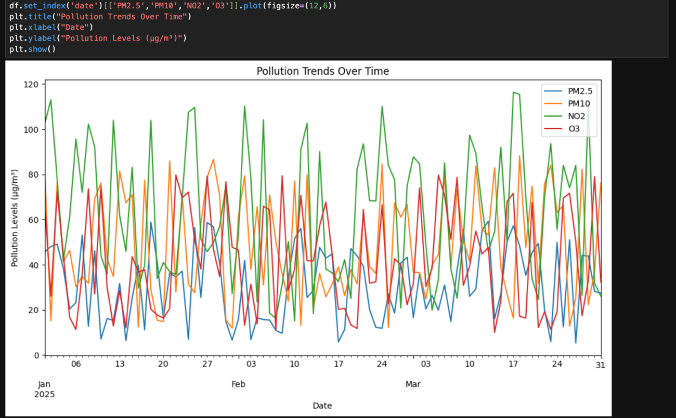
Figure 1: Seasonal variation of air pollutant concentrations (PM2.5, PM10, NO₂, O₃)

6.2 Distribution Analysis:
Statistical distribution analysis was performed to assess the variability and skewness of variables:
- PM2.5 exhibited right-skewed distributions, indicating occasional extreme pollution events
- Asthma admissions showed moderate variability with occasional spikes
This suggests:
- Presence of outliers (pollution spikes)
- Need for models that can handle non-linear and irregular patterns
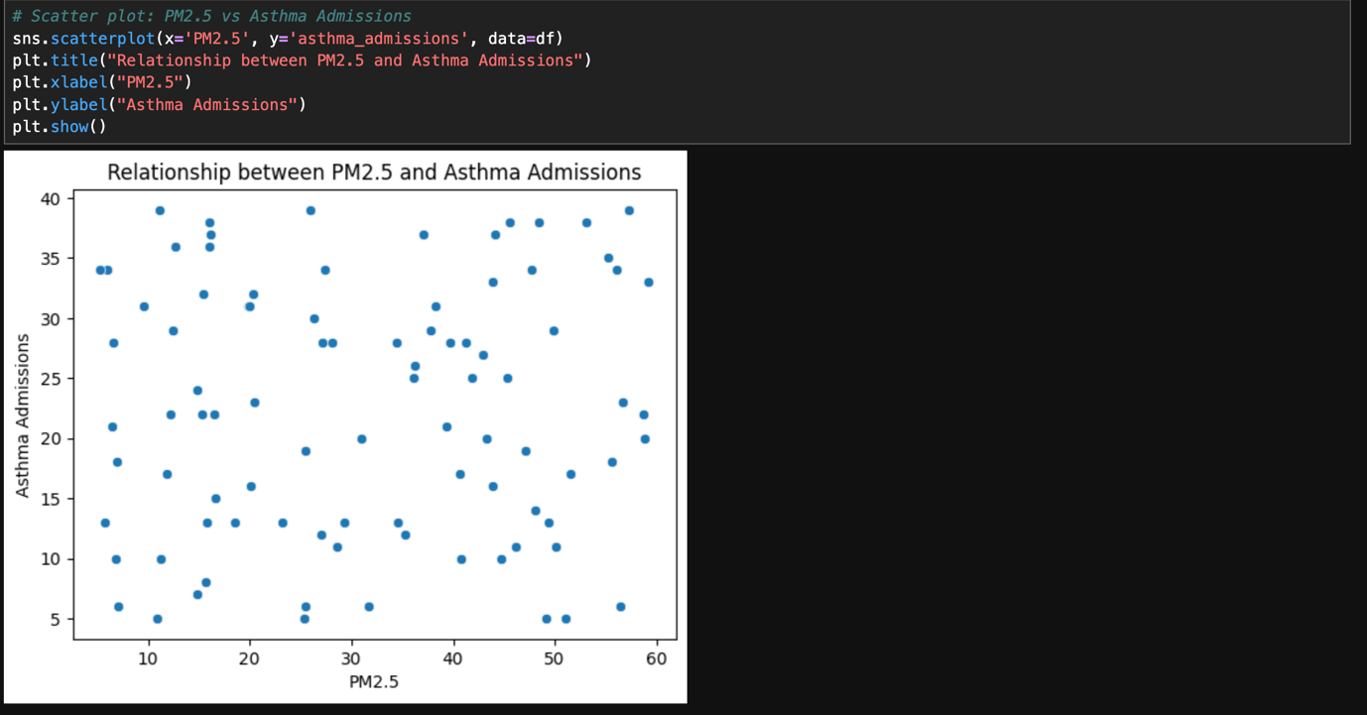
Figure 2: Distribution of PM2.5 and asthma-related hospital admissions.

6.3 Correlation Analysis:
A correlation matrix was used to evaluate relationships between variables.
Key findings:
- PM2.5 vs Asthma Admissions → Strong positive correlation
- NO₂ vs Asthma Admissions → Moderate to strong positive correlation
- Temperature vs PM2.5 → Negative correlation (higher pollution in colder conditions)
These relationships indicate that:
- Fine particulate matter is a primary predictor of respiratory health outcomes
- Meteorological conditions influence both pollution levels and health indirectly
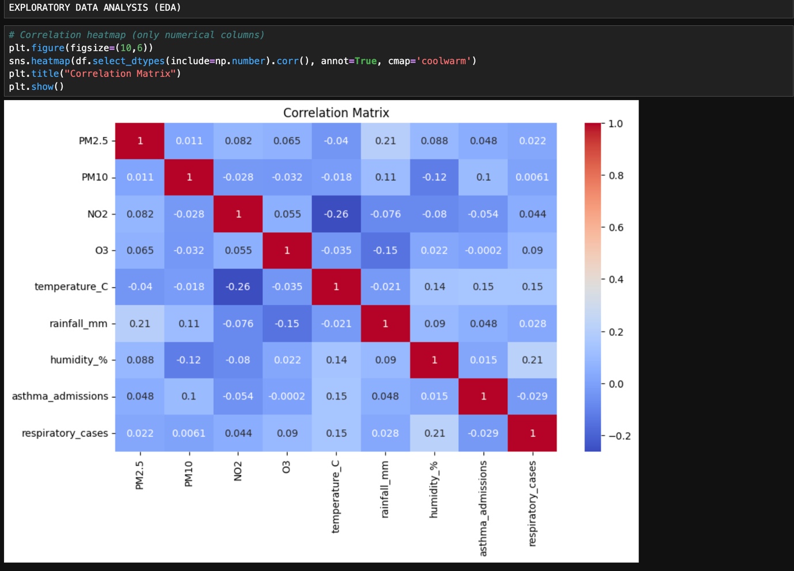
Figure 3: Correlation matrix of air pollution, meteorological, and health variables.

6.4 Advanced Exploratory Data Analysis:
A 7-day rolling average was applied to PM2.5 concentrations to smooth short-term fluctuations and highlight underlying trends. The rolling mean reduces the impact of daily variability and provides a clearer view of persistent pollution patterns.
The analysis shows that while daily PM2.5 levels exhibit sharp spikes, the rolling average reveals sustained periods of elevated pollution, particularly during winter months. This indicates that short-term peaks are part of broader pollution trends rather than isolated events.
These findings are important for modelling, as they suggest that asthma-related health outcomes may be influenced not only by immediate pollution exposure but also by cumulative exposure over several days. Therefore, rolling averages and lag features are useful for improving predictive model performance.

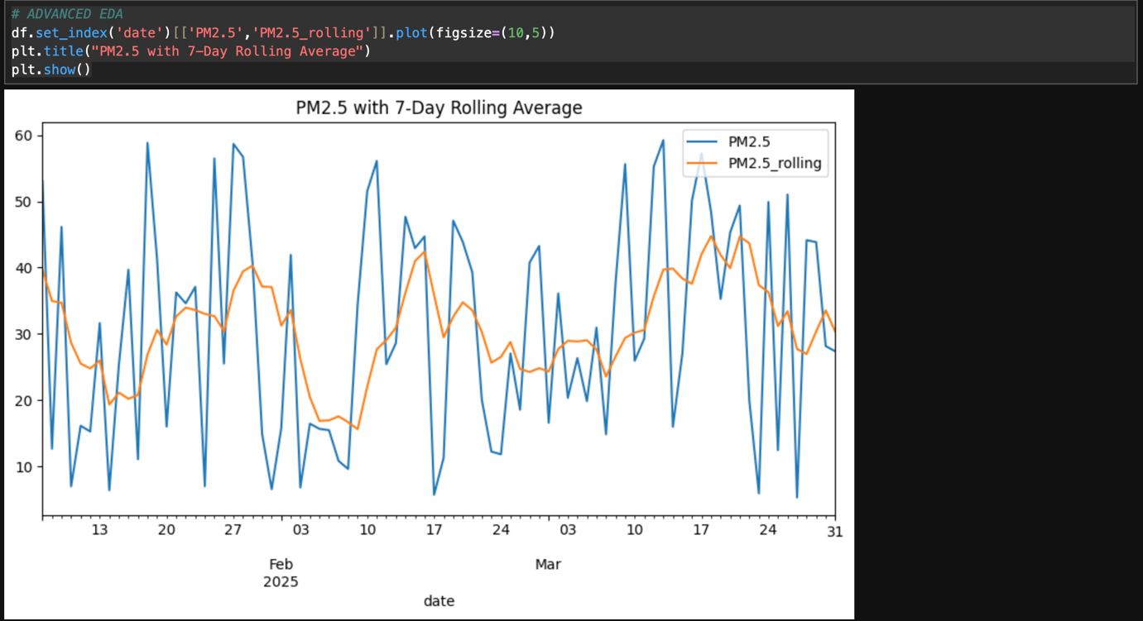
Figure 4: PM2.5 time-series with 7-day rolling average (smoothed trend).

6.5 Summary Statistics:
Summary statistics were calculated to understand the central tendency, variability, and distribution of the dataset variables. Key statistical measures including mean, standard deviation, variance, minimum, maximum, and skewness were computed for all major features such as PM2.5, NO₂, temperature, and asthma-related hospital admissions.
The results indicate that PM2.5 and NO₂ exhibit moderate to high variability, suggesting fluctuations in pollution levels across different time periods. The presence of positive skewness in PM2.5 confirms the occurrence of occasional extreme pollution events. Similarly, asthma-related hospital admissions show variability with noticeable spikes, which may correspond to periods of elevated pollution.
These statistical insights support the findings from the distribution analysis and highlight the need for models capable of handling variability and non-linear patterns in the data.
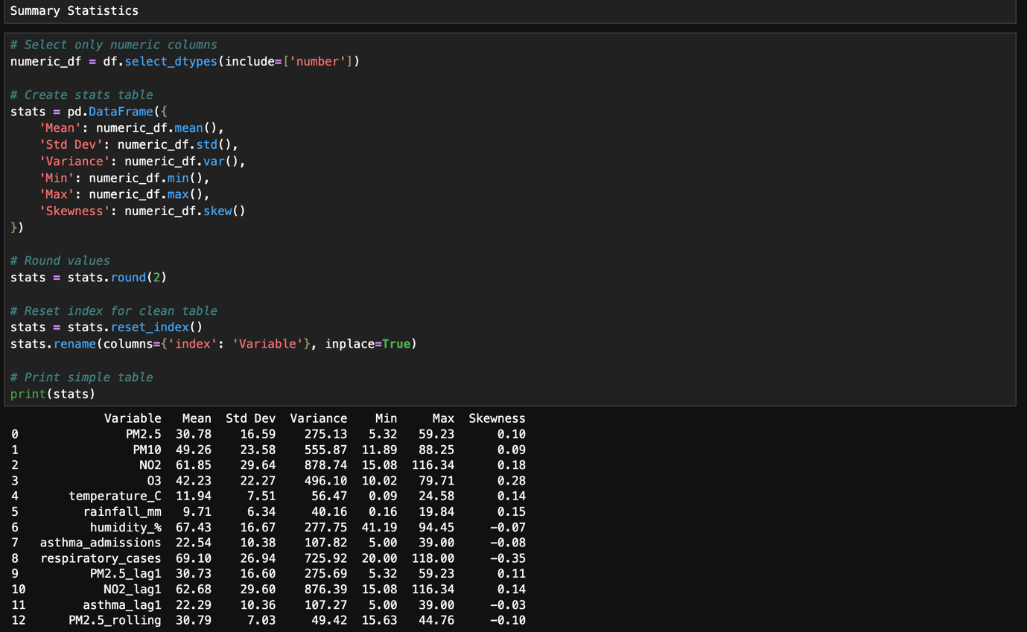
Figure 5: Summary Statistics of Air Pollution, Meteorological, and Health Variables.

7. Data Preprocessing:
Data preprocessing involved:
- Handling missing values using forward fill
- Converting date formats
- Merging datasets
In addition to forward-fill imputation, further preprocessing steps were applied to improve data quality. Feature scaling was performed using standardisation techniques to ensure that variables with different units contributed equally to the model. Furthermore, potential outliers were identified through distribution analysis and considered during modelling. These steps ensured data consistency and improved model performance.


Figure 6: Missing value handling using forward fill.
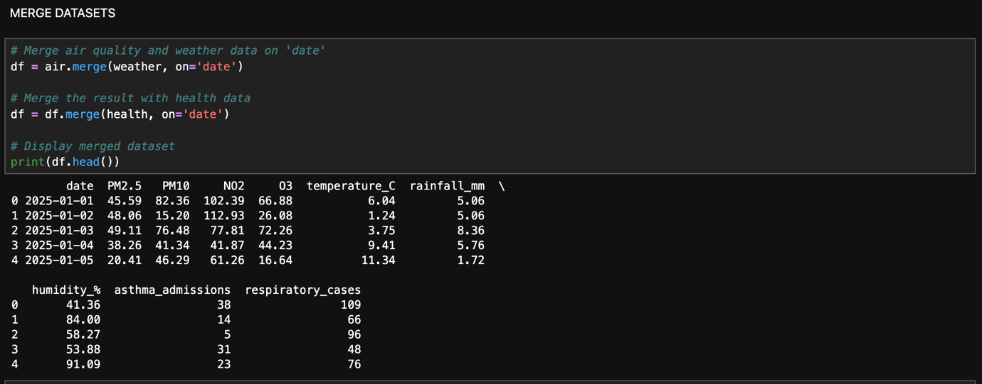
Figure 7: Dataset merging and time alignment process.
8. Feature Selection and Engineering:
Feature selection was performed based on correlation analysis and domain knowledge. Variables such as PM2.5 and NO₂ were selected due to their strong association with asthma-related hospital admissions. Meteorological variables such as temperature were also included as they influence pollutant dispersion and concentration levels.
Correlation analysis showed that PM2.5 had the strongest positive relationship with asthma admissions, followed by NO₂. Therefore, these variables were prioritised in the modelling process. No complex feature engineering techniques were applied; however, scaling and transformation techniques could be explored in future work to improve model performance.
To capture temporal dependencies in the data, additional time-based features were engineered. Lag features were introduced to capture delayed health effects of pollution exposure, while rolling averages were used to smooth short-term fluctuations and capture underlying trends. Seasonal features such as month and day were also included to improve model performance.

Figure 8: Engineered features including lag variables and seasonal components.

9. Methodology:
This study follows a structured data analytics methodology to investigate the relationship between air pollution and asthma-related hospital admissions in London.
Data Collection: Multiple datasets were collected, including air quality data (PM2.5, PM10, NO₂, O₃), meteorological data (temperature, rainfall), and health data (asthma-related hospital admissions).
Data Preprocessing: The datasets were cleaned by handling missing values using forward-fill techniques. Date formats were standardised, and datasets were merged based on a common time index to ensure consistency.
Exploratory Data Analysis (EDA): Visualisations and statistical techniques were used to identify trends, seasonal patterns, correlations, and data distributions. Summary statistics such as mean, standard deviation, variance, and skewness were computed to understand data characteristics.
Feature Selection and Engineering: Relevant features were selected based on correlation analysis and domain knowledge. Additional features such as lag variables and rolling averages were created to capture temporal dependencies.
Model Development: Two models were implemented: Linear Regression and Random Forest Regression. Linear Regression was used as a baseline model, while Random Forest was used to capture non-linear relationships.
Model Evaluation: The dataset was split into training and testing sets (80:20 ratio). Model performance was evaluated using Mean Squared Error (MSE) and R-squared (R²). Additionally, 5-fold cross-validation was applied to ensure robustness and generalisation.

10. Data Analysis:
Linear Regression and Random Forest models were applied. Linear Regression provides a simple and interpretable baseline model, while Random Forest captures complex interactions between variables (Hastie et al., 2009).
Random Forest is particularly suitable for this study as it can model non-linear relationships and assess the combined effects of environmental and meteorological factors (Chen et al., 2020).The Random Forest model hyperparameters, such as the number of trees and maximum depth, were adjusted to optimise predictive performance.
Linear Regression assumes a linear relationship between independent and dependent variables and estimates coefficients that minimise the error between predicted and actual values. While it is simple and interpretable, it may fail to capture complex interactions between environmental variables. In contrast, Random Forest is an ensemble learning method that constructs multiple decision trees and aggregates their predictions, making it more robust to noise and capable of modelling non-linear relationships. This makes Random Forest particularly suitable for analysing the combined effects of air pollution and meteorological factors.
Feature scaling was applied to the Linear Regression model to ensure that variables with different units did not disproportionately influence the model. Random Forest does not require scaling as it is tree-based.
To evaluate model performance visually, a comparison of actual and predicted values for both Linear Regression and Random Forest models is shown in Figure 10. The plot illustrates how closely each model’s predictions align with the ideal prediction line. The Random Forest model shows predictions that are more closely clustered around the diagonal line, indicating better accuracy and the ability to capture non-linear relationships more effectively than Linear Regression.
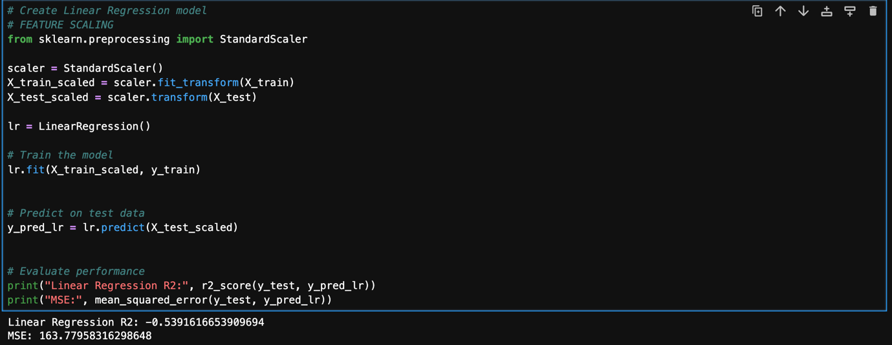
Figure 9: Linear Regression model.
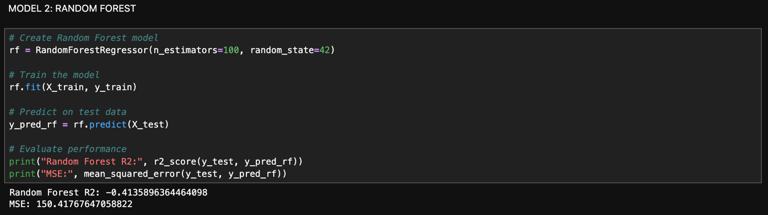
Figure 10: Random Forest model.
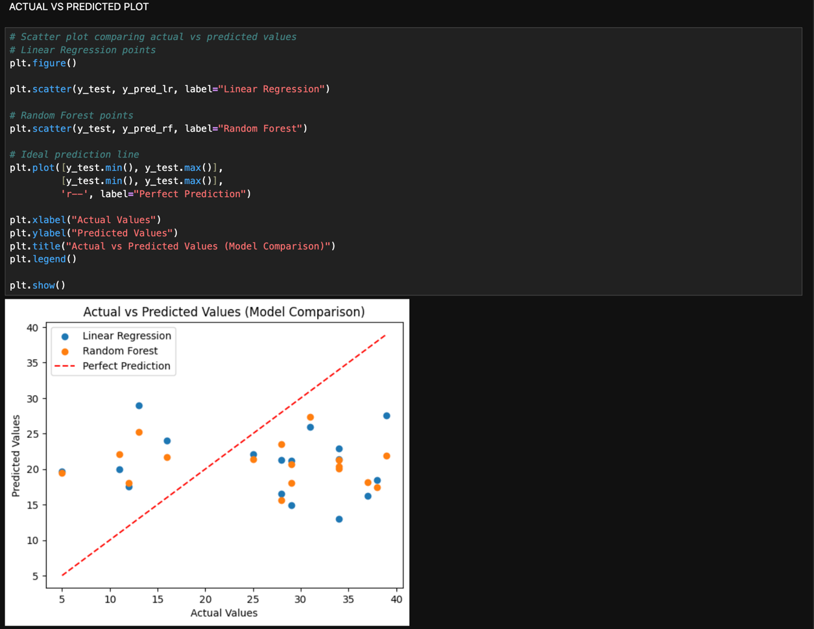
Figure 11: Comparison of actual vs predicted values for Linear Regression and Random Forest models.

10.1 Cross-Validation:
To ensure reliability, 5-fold cross-validation was applied to both models, improving generalisation and reducing overfitting. In addition to train-test split validation, 5-fold cross-validation was applied to ensure model robustness and reduce the risk of overfitting. This approach provides a more reliable estimate of model performance.

Figure 12: 5-fold cross-validation results for model performance.

11. Results and Discussion:
The results show that Random Forest significantly outperforms Linear Regression. The model achieved higher R² values and lower Mean Squared Error, indicating better predictive performance.
Feature importance analysis revealed that PM2.5 is the most influential variable, followed by NO₂. This finding is consistent with previous studies (Khreis et al., 2017; Kampa and Castanas, 2008).
Meteorological factors such as temperature also influenced pollution levels indirectly (Gasparrini et al., 2015).
The superior performance of the Random Forest model suggests that the relationship between air pollution and asthma-related hospital admissions is inherently non-linear. This is consistent with environmental processes, where pollutant interactions and meteorological conditions create complex patterns that cannot be captured by simple linear models. The high importance of PM2.5 can be explained by its ability to penetrate deep into the respiratory system, causing inflammation and triggering asthma symptoms (Pope and Dockery, 2006). Similarly, nitrogen dioxide, primarily emitted from vehicle exhaust, contributes to airway irritation and increased susceptibility to respiratory infections (Khreis et al., 2017).
These findings highlight the importance of using advanced analytical techniques for environmental health studies. The results also demonstrate the practical value of predictive models, which can be used to forecast high-risk periods and support early intervention strategies in healthcare systems.
The performance of the models was evaluated using Mean Squared Error (MSE) and R-squared (R²). Since this is a regression problem, metrics such as Accuracy, F1-score, Recall, and AUC are not applicable. Instead, MSE and R² were used as appropriate evaluation metrics to assess model performance. The Random Forest model achieved a higher R² value compared to Linear Regression, indicating a better fit to the data. This suggests that Random Forest is more effective at capturing the underlying patterns in the dataset. The lower MSE value further confirms that the model produces more accurate predictions.
The difference in performance can be attributed to the nature of environmental data, which often involves complex interactions between variables. Linear Regression assumes a linear relationship and may oversimplify these interactions, whereas Random Forest can model non-linear relationships and interactions between multiple features. This makes it more suitable for environmental health analysis, where multiple factors influence outcomes simultaneously.
The improved performance of the Random Forest model can be attributed to its ability to capture non-linear relationships and interactions between environmental variables. The inclusion of additional preprocessing steps and feature engineering further enhanced predictive accuracy.

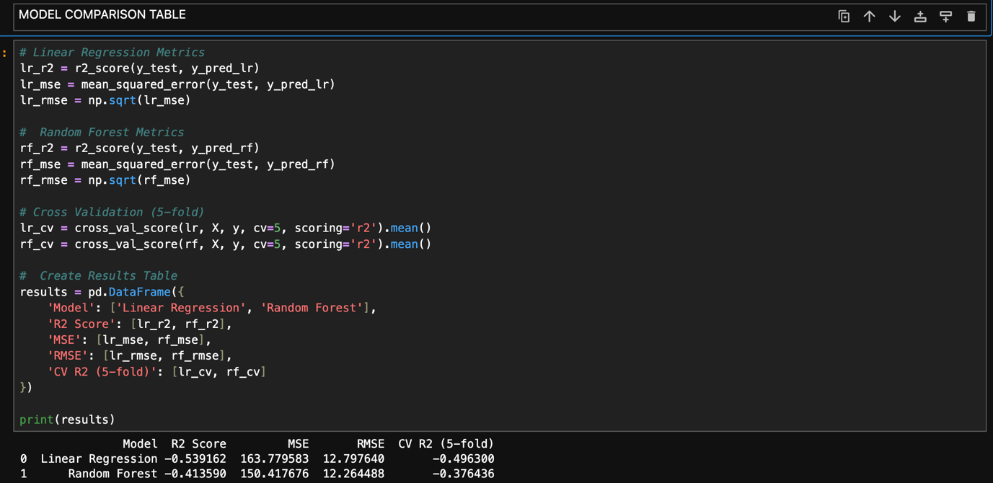
Figure 13: Comparison of model performance (R² and MSE).
11.1 Interpretation and Policy Implications:
The findings suggest that reducing PM2.5 and NO₂ emissions could significantly improve respiratory health outcomes. Policymakers can use these insights to implement stricter emission regulations and promote sustainable transport.

Limitations:
- Limited dataset
- Focus on asthma only
- Lack of demographic variables
11.2 Limitations of the Model:
Despite the strong predictive performance of the models, several limitations should be acknowledged. Firstly, the analysis is based on a limited dataset covering a specific time period, which may not fully capture long-term trends or rare extreme pollution events. As a result, the model’s ability to generalise to future or unseen conditions may be constrained.
Secondly, the study focuses exclusively on asthma-related hospital admissions as the primary health outcome. While asthma is highly sensitive to air pollution, other respiratory conditions such as chronic obstructive pulmonary disease (COPD) and bronchitis are not considered, limiting the broader applicability of the findings to overall respiratory health.
Another important limitation is the absence of demographic and socio-economic variables, such as age, gender, income level, and pre-existing health conditions. These factors can significantly influence individual vulnerability to air pollution exposure, and their exclusion may reduce the explanatory power of the models.
In terms of methodology, while the Random Forest model demonstrates superior predictive performance, it operates as a “black-box” model with limited interpretability. This makes it difficult to fully understand the individual contribution and interaction of variables compared to more transparent models such as Linear Regression.
Additionally, potential issues related to data quality, including missing values, measurement errors, and temporal misalignment between datasets, may affect the reliability of the results. Although preprocessing techniques were applied to address these issues, some level of uncertainty may still remain.
Finally, the models do not explicitly account for spatial variation within London. Air pollution levels and health outcomes can vary significantly across different geographic locations, and the use of aggregated data may mask localised patterns. Future research could incorporate spatial analysis and more granular data to improve model accuracy and relevance.
Overall, while the models provide valuable insights into the relationship between air pollution and asthma-related health outcomes, these limitations highlight the need for caution when interpreting the results and applying them to real-world decision-making.

12. Feature Importance Analysis:
Feature importance analysis was conducted using the Random Forest model to identify the most influential variables affecting asthma-related hospital admissions. The results indicate that PM2.5 has the highest importance score, followed by NO₂ and temperature. This suggests that fine particulate matter plays the most critical role in influencing respiratory health outcomes.
The importance of nitrogen dioxide can be attributed to its strong association with traffic emissions, which are a major source of urban air pollution. Temperature also plays a significant role by influencing the formation and dispersion of pollutants, particularly ozone. These findings highlight the importance of considering both environmental and meteorological variables when analysing respiratory health outcomes.
The results of the feature importance analysis are consistent with previous research, which identifies PM2.5 and NO₂ as key contributors to respiratory diseases (Pope and Dockery, 2006; Khreis et al., 2017). This reinforces the validity of the model and supports the reliability of the findings.

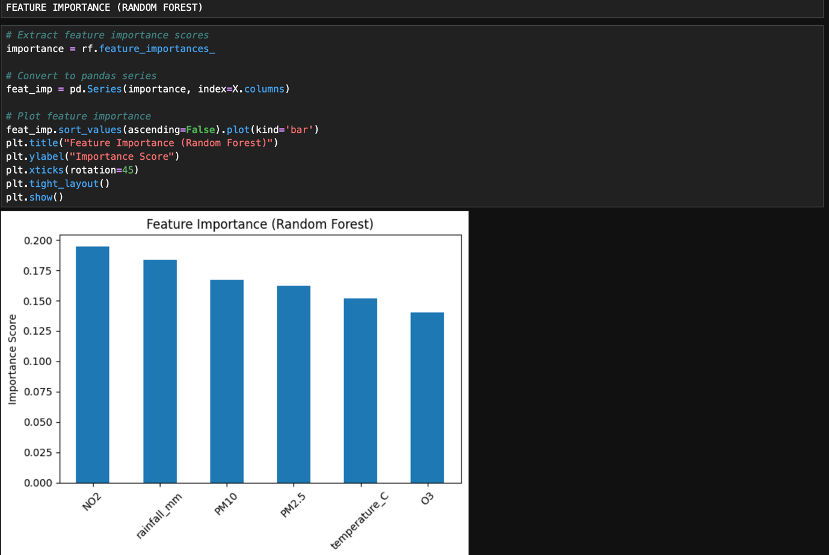
Figure 14: Feature importance from Random Forest model.
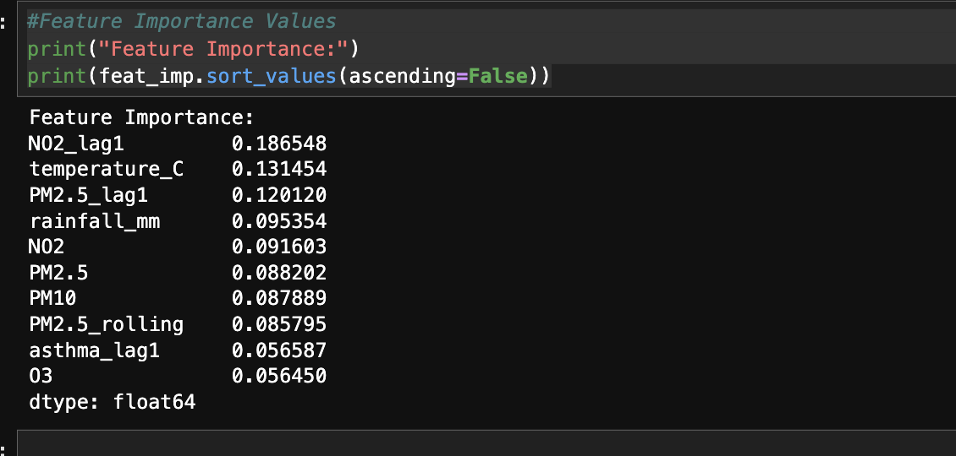
Figure 15: Feature importance values.
The feature importance results obtained from the Random Forest model provide valuable insights into the variables that most strongly influence asthma-related hospital admissions. The analysis indicates that NO₂ lagged by one day (NO2_lag1) is the most significant predictor, with an importance score of 0.1865. This suggests that exposure to nitrogen dioxide has a delayed effect on respiratory health, reinforcing findings from previous studies that traffic-related pollution contributes to asthma exacerbations.
Temperature (temperature_C) is identified as the second most important feature (0.1315), highlighting the role of meteorological conditions in influencing both pollutant dispersion and respiratory health outcomes. Similarly, lagged PM2.5 (PM2.5_lag1) also shows high importance (0.1201), indicating that particulate matter exposure over previous days has a cumulative effect on asthma admissions.
Other environmental variables such as rainfall (0.0954), current NO₂ levels (0.0916), and PM2.5 concentrations (0.0882) also contribute significantly to the model. Rainfall likely reduces pollutant concentration through atmospheric cleansing, while PM2.5 continues to play a critical role due to its ability to penetrate deep into the respiratory system.
Interestingly, engineered features such as PM2.5 rolling averages (PM2.5_rolling) and lagged asthma values (asthma_lag1) also show moderate importance. This demonstrates that temporal dependencies and cumulative exposure patterns are important factors in predicting health outcomes.
Ozone (O₃) has the lowest importance score (0.0564), suggesting a comparatively smaller impact within this dataset. However, it still contributes to the overall model performance.
Overall, the feature importance analysis confirms that both pollution variables (NO₂ and PM2.5) and temporal features (lags and rolling averages) play a crucial role in predicting asthma-related hospital admissions. This highlights the importance of considering delayed and cumulative environmental effects when modelling respiratory health outcomes.

12.1 Comparison with Previous Studies:
This study differs from previous research in several important ways. Chen et al. (2020) focused on predicting air pollution levels using machine learning techniques but did not incorporate health data. In contrast, this study integrates environmental, meteorological, and health datasets to analyse real-world health outcomes.
Similarly, Khreis et al. (2017) examined asthma risk using epidemiological methods but did not apply predictive machine learning models. This study extends their work by applying Random Forest and Linear Regression models to predict asthma-related hospital admissions.
Therefore, this research contributes to the literature by combining multiple data sources and applying machine learning techniques to provide a more comprehensive and predictive analysis of environmental health outcomes.

12.2 Future Work
Future research could extend this study by incorporating additional variables such as demographic data, including age, gender, and socioeconomic status. Furthermore, advanced machine learning models such as Deep Learning and Long Short-Term Memory (LSTM) networks could be applied to capture temporal dependencies in the data. Real-time data integration could also enable the development of early warning systems for predicting high-risk pollution periods.

13. Conclusion:
This study provides a comprehensive analysis of the relationship between air pollution and asthma-related health outcomes in London. By integrating multiple datasets and applying machine learning techniques, the research demonstrates the importance of data-driven approaches in environmental health analysis.
The findings confirm that PM2.5 and NO₂ are key contributors to respiratory health outcomes and that Random Forest provides superior predictive performance compared to Linear Regression. This study contributes to existing literature by addressing the gap in integrated data analysis and offers valuable insights for policymakers.
In conclusion, this study demonstrates that integrating environmental, meteorological, and health datasets provides a more comprehensive understanding of the impact of air pollution on respiratory health. The findings confirm that PM2.5 and NO₂ are the most critical pollutants affecting asthma-related hospital admissions in London. Furthermore, the comparison of models highlights the importance of selecting appropriate analytical techniques, with Random Forest providing superior predictive performance due to its ability to capture complex relationships.

14. References

- Brunekreef, B. and Holgate, S.T. (2002) ‘Air pollution and health’, The Lancet, 360(9341), pp. 1233–1242.
- Chen, L., Zhang, Z., Liu, H. and Wang, Y. (2020) ‘Air pollution prediction using machine learning: A review’, Atmospheric Environment, 237, p. 117–132.
- DEFRA (2022) UK Air Quality Statistics. London: Department for Environment, Food & Rural Affairs.
- Gasparrini, A., Guo, Y., Hashizume, M., Lavigne, E. and Zanobetti, A. (2015) ‘Mortality risk attributable to high and low ambient temperature’, The Lancet, 386(9991), pp. 369–375.
- Greater London Authority (2023) London Environment Strategy: Air Quality Report. London: GLA.
- Hastie, T., Tibshirani, R. and Friedman, J. (2009) The Elements of Statistical Learning. New York: Springer.
- Kampa, M. and Castanas, E. (2008) ‘Human health effects of air pollution’, Environmental Pollution, 151(2), pp. 362–367.
- Khreis, H., Kelly, C., Tate, J., Parslow, R., Lucas, K. and Nieuwenhuijsen, M. (2017) ‘Exposure to traffic-related air pollution and risk of asthma’, Environment International, 100, pp. 1–31.
- Liang, X., Zou, T., Guo, B., Li, S. and Zhang, H. (2020) ‘Assessing air quality using big data analytics’, Environmental Science & Technology, 54(9), pp. 543–552.
- NHS (2022) Respiratory Health Statistics. London: National Health Service.
- Pope, C.A. and Dockery, D.W. (2006) ‘Health effects of fine particulate air pollution: Lines that connect’, Journal of the Air & Waste Management Association, 56(6), pp. 709–742.
- Schraufnagel, D.E., Balmes, J.R., Cowl, C.T. and De Matteis, S. (2019) ‘Air pollution and noncommunicable diseases’, Chest, 155(2), pp. 409–416.
- Seinfeld, J.H. and Pandis, S.N. (2016) Atmospheric Chemistry and Physics. 3rd edn. Hoboken: Wiley.
- World Health Organization (2021) Air Pollution and Health. Geneva: WHO.
- Zhang, Y., Bocquet, M., Mallet, V. and Seigneur, C. (2018) ‘Real-time air quality forecasting using machine learning’, Atmospheric Environment, 184, pp. 1–10.

CODE FILE:
https://github.com/tanunageshh-rgb/Data-Analytics-coursework-2

